**MAVEN ASSIGNMENT**

**LOCAL JENKINS**

**1.**Buildinga project using maven tool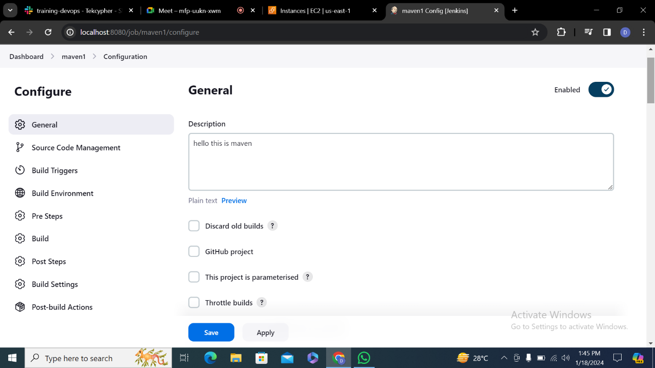

**2.** Enter git hub repository

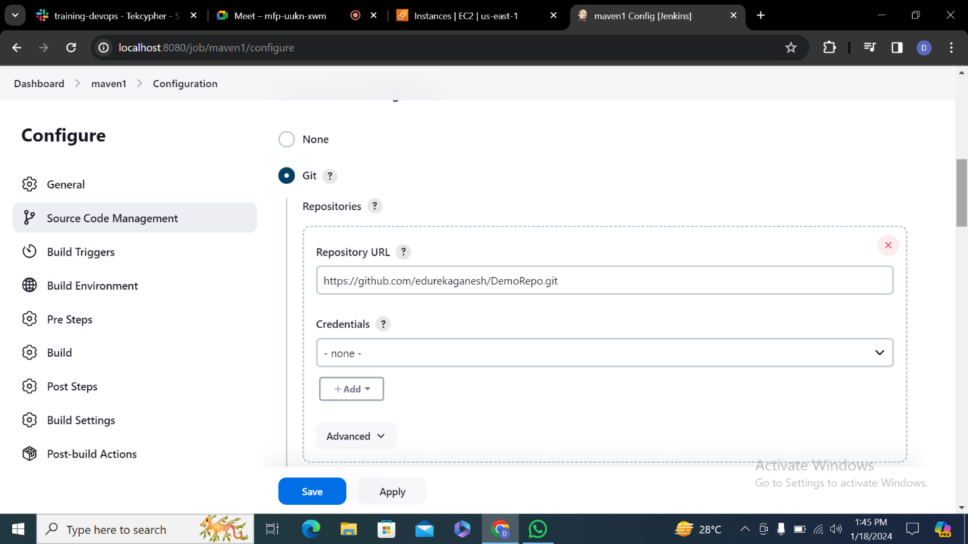

**3.** In Goal options make sure you type clean compile package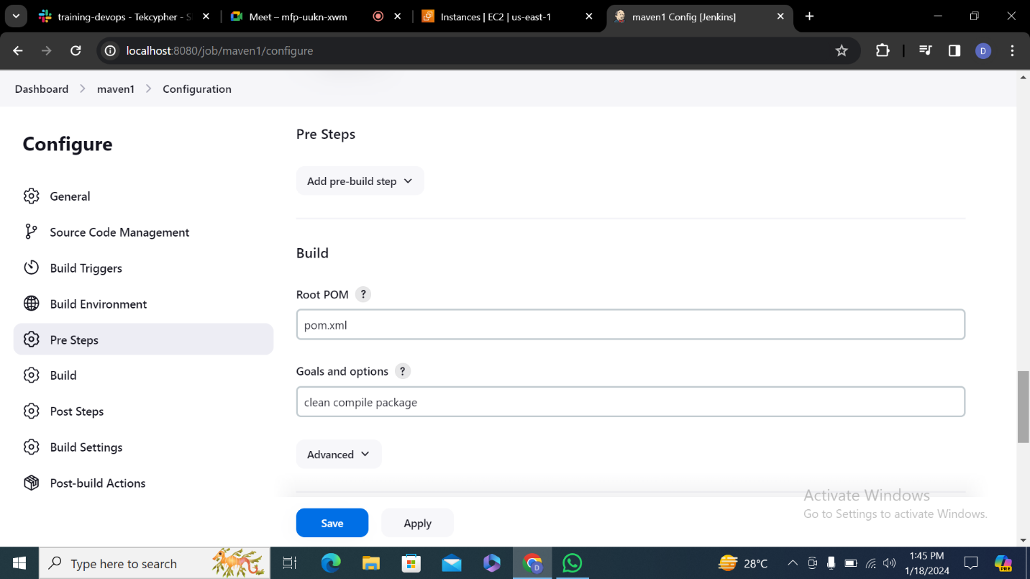

**4.**Click on build now check weather it is successful or not

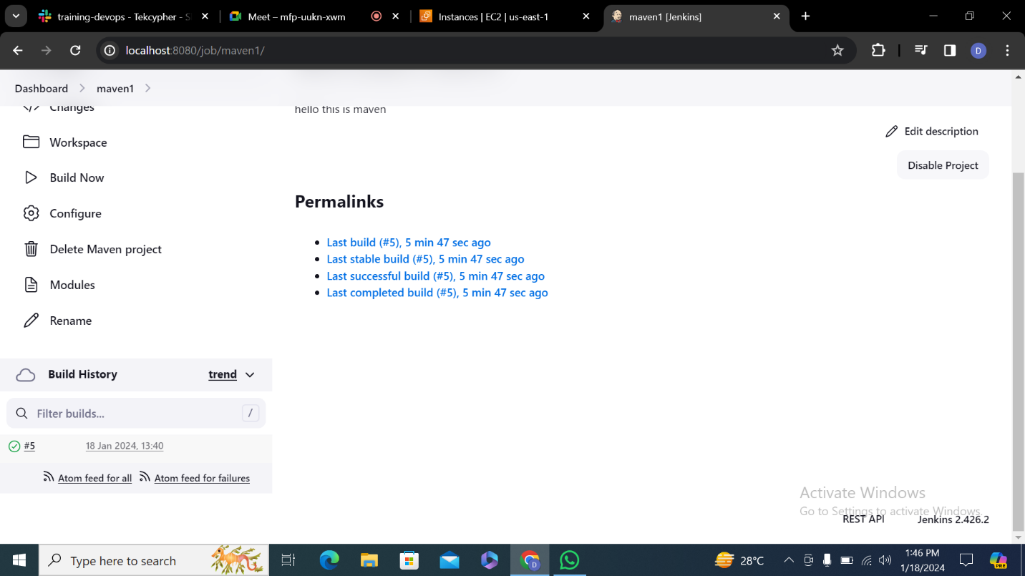

**5.**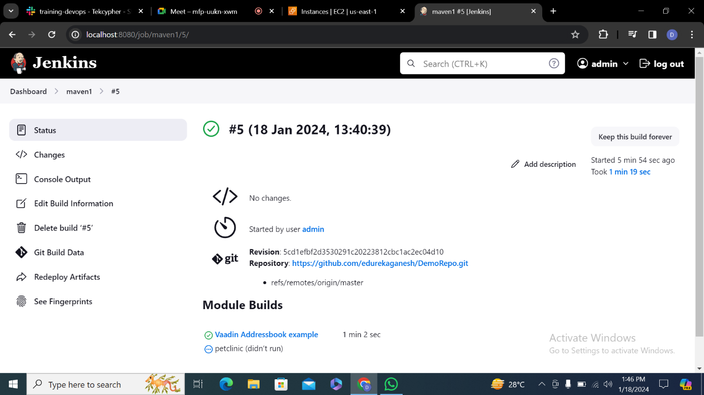

**6.**

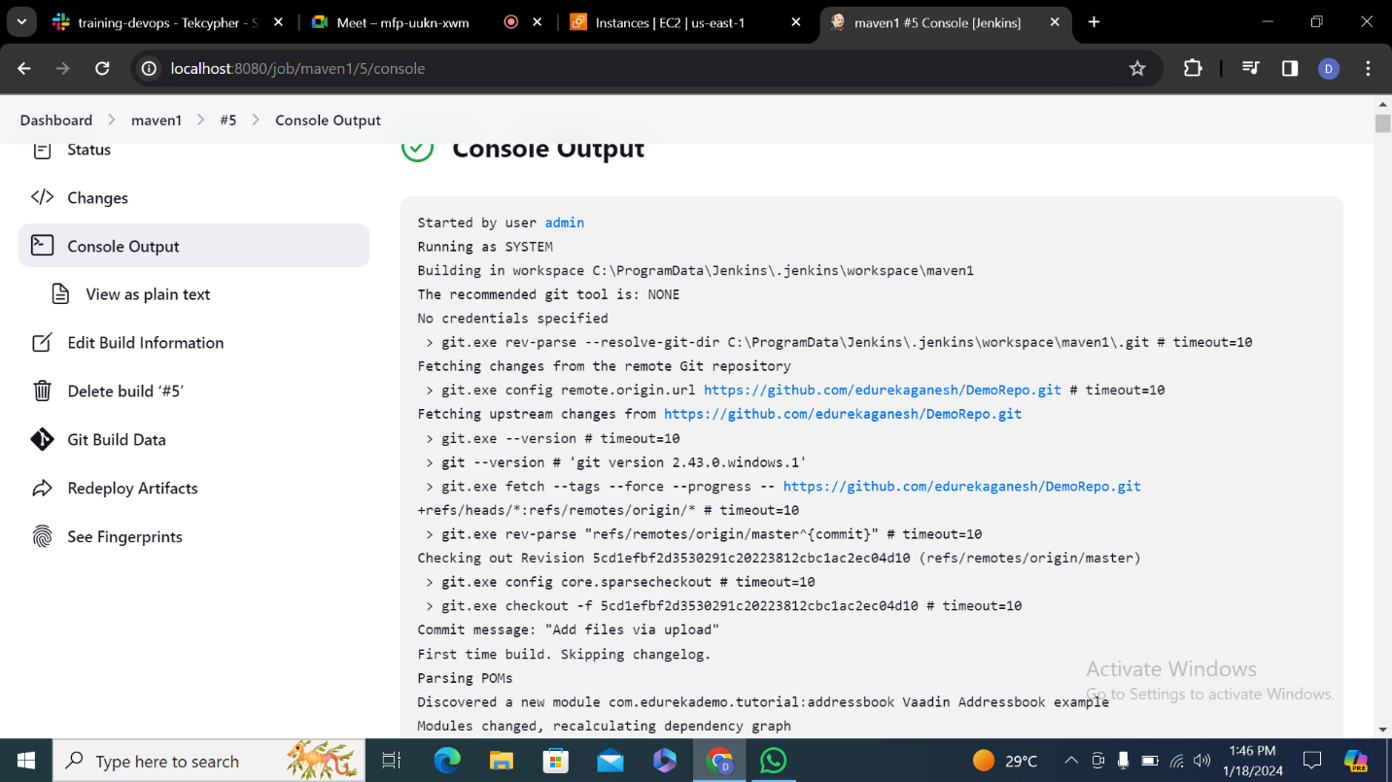

**7.**

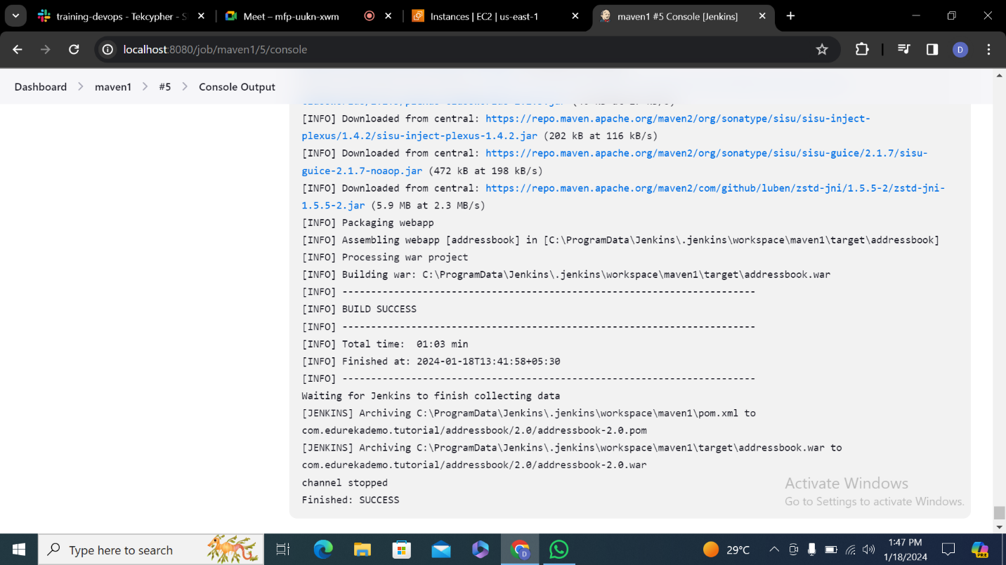

**8.**

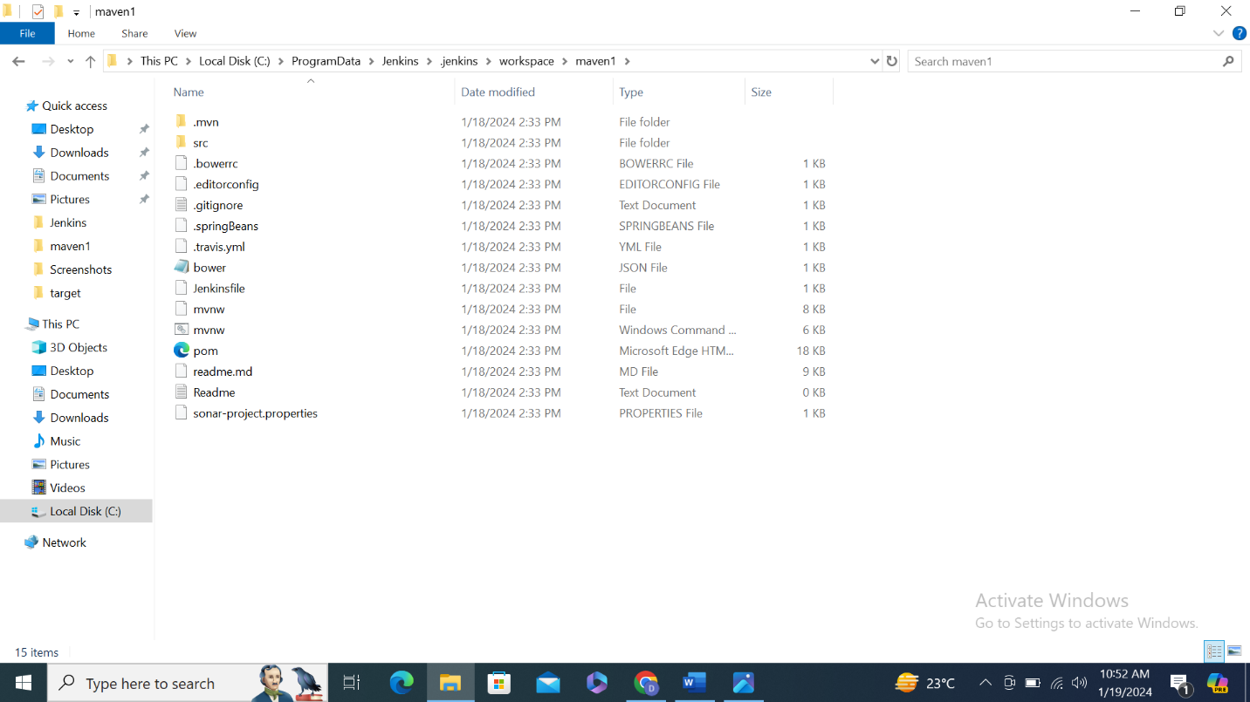

**MAVEN IN ONLINE HOSTING**

**1.**Building project using maven tool in online hosting

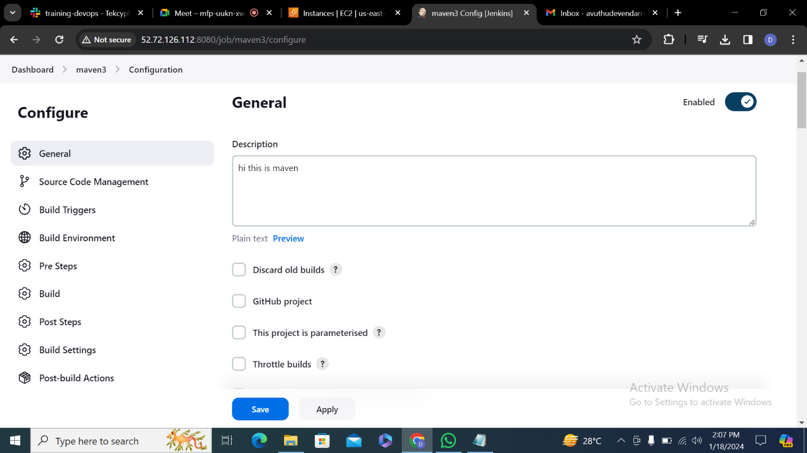

**2.**Enter git hub repository

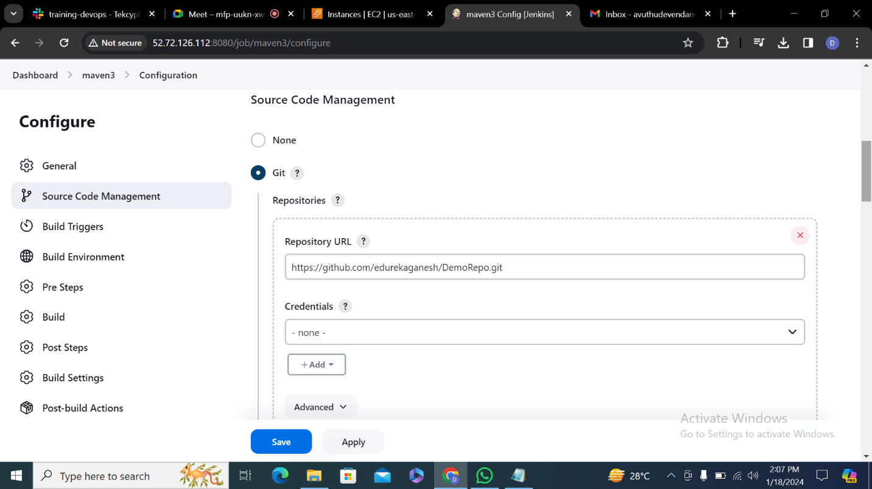

**3.**In goals and options make you type clean compile package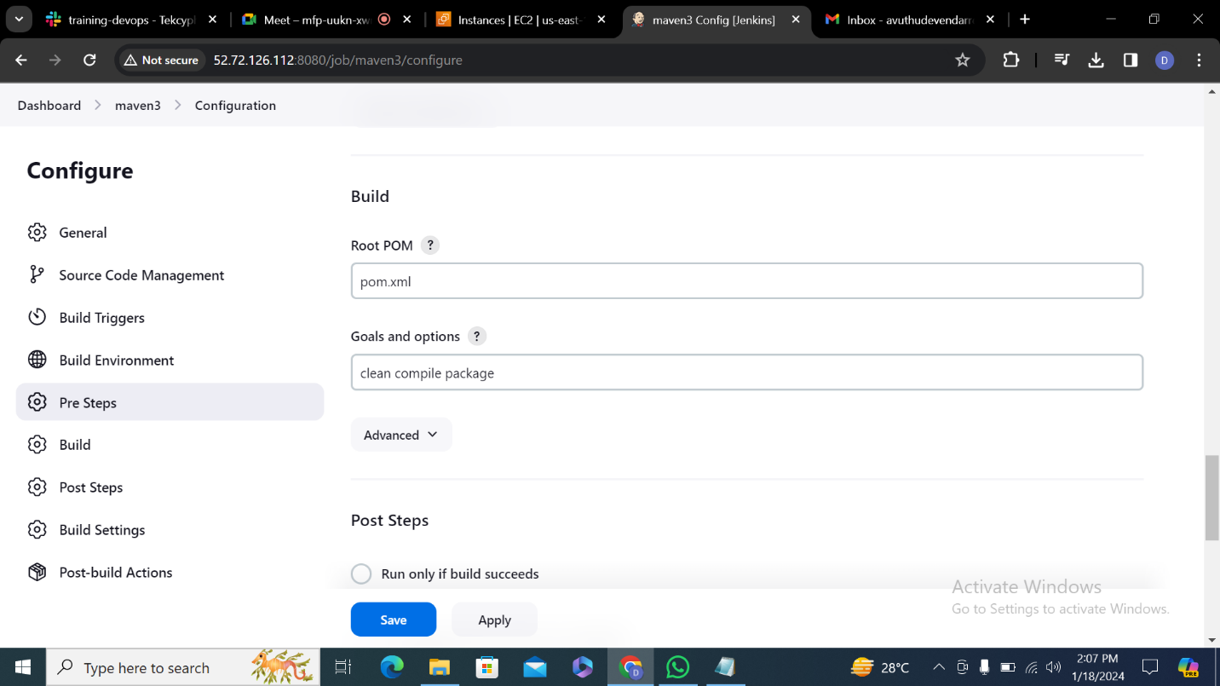

**4.**Click on build now and make sure it is successful or not

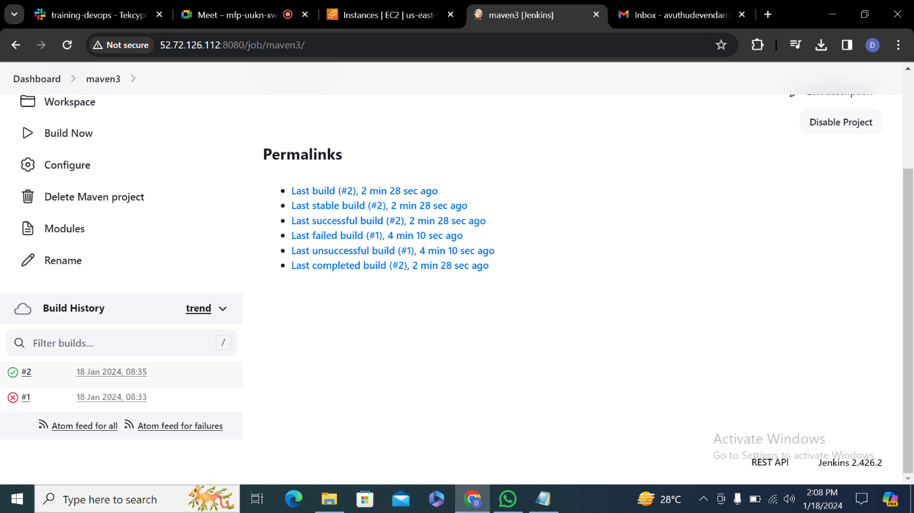

**5.**



**7.**

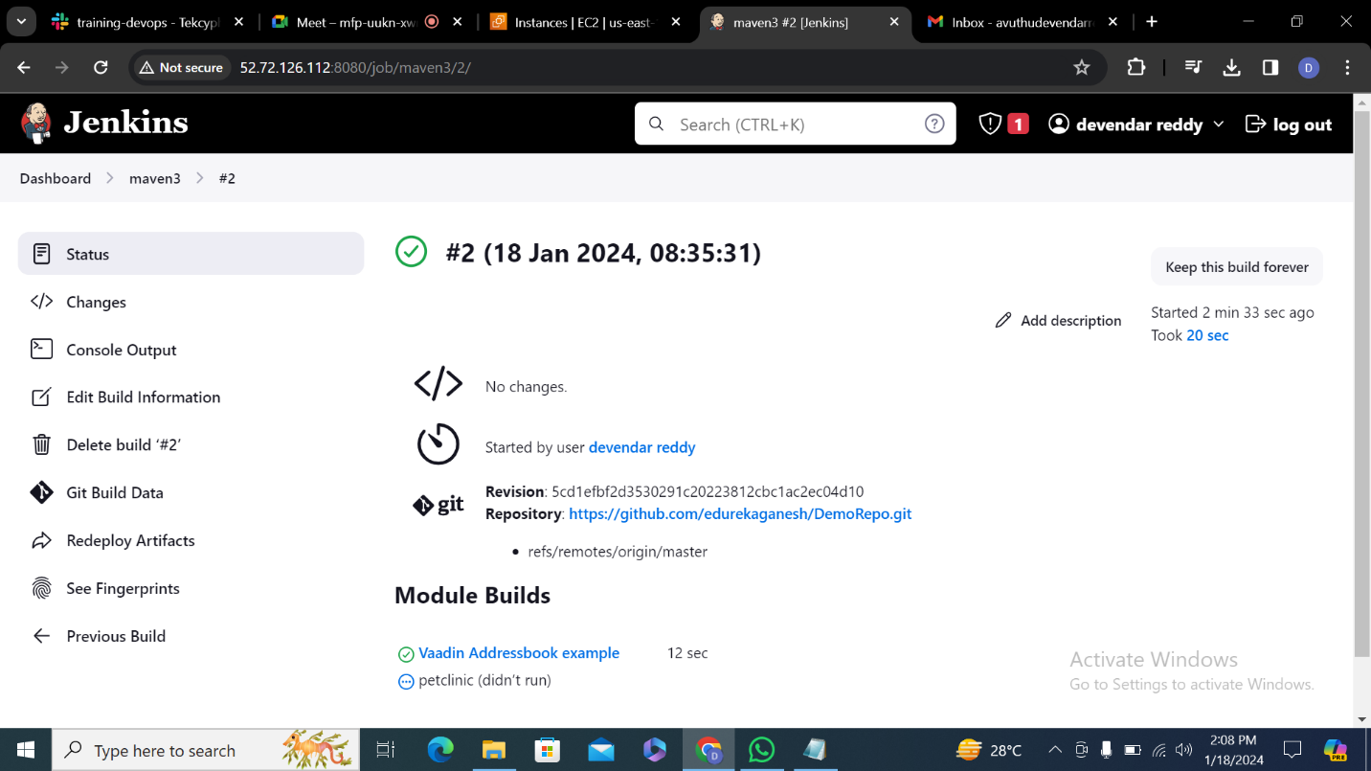

**8.**

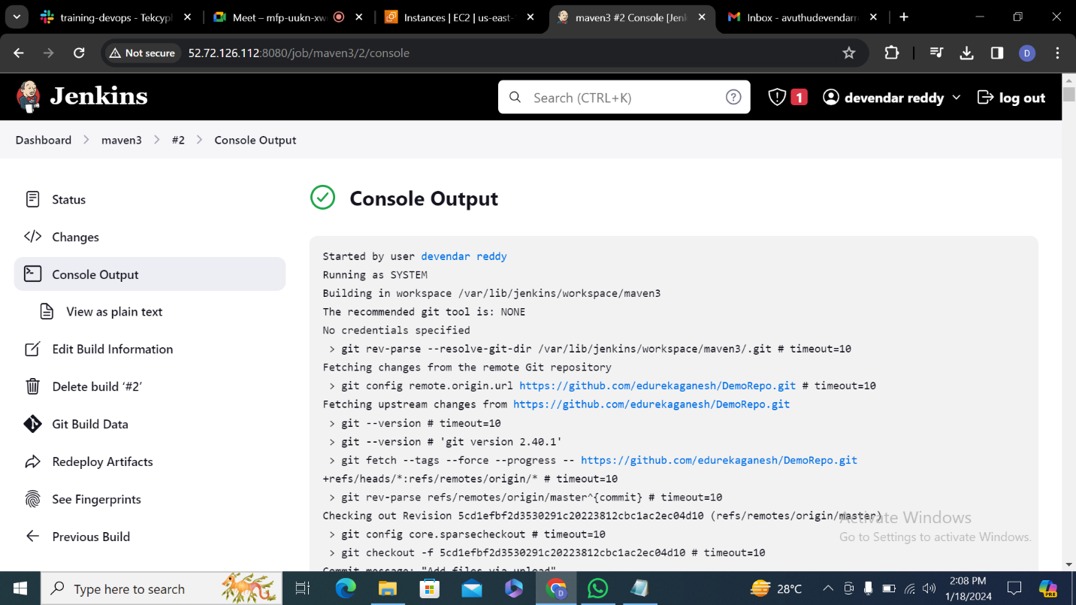

**9.**

